Prop # | 1
Prop Name: | Switchboard
Prop Type: | Set Dressing
Script Location: | 1 | 1
Character: | Telephone Operator
Quantity: | 1
Research Images: | 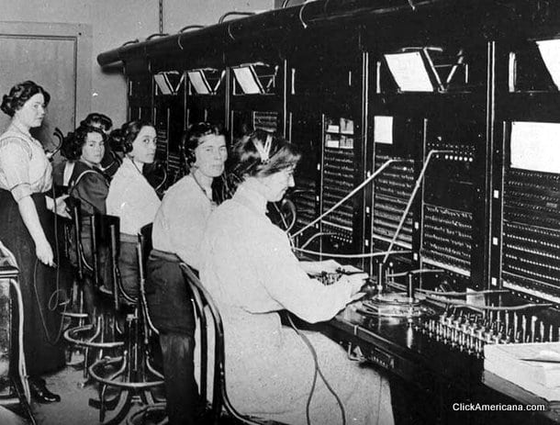

Notes: | Interactive, table-size

Prop # | 2
Prop Name: | Filing Cabinet
Prop Type: | Furniture
Script Location: | 1 | 1
Character: | Filing Clerk
Quantity: | 1
Research Images: | 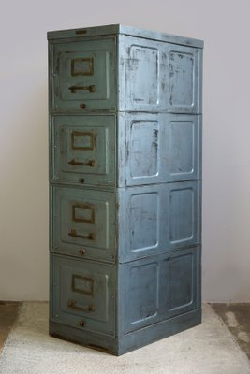

Notes: | Should have file folders within it

Prop # | 3
Prop Name: | Adding Machine
Prop Type: | Set Dressing
Script Location: | 1 | 1
Character: | Adding Clerk
Quantity: | 1
Research Images: | 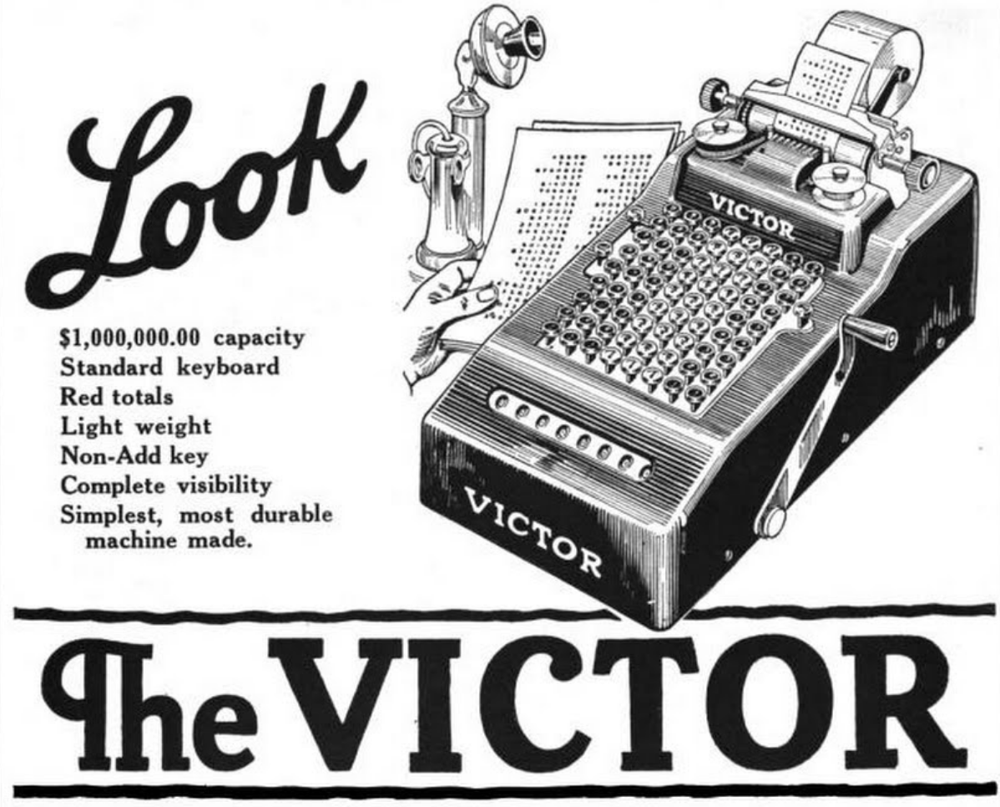

Notes:

Prop # | 4
Prop Name: | Typewriter
Prop Type: | Set Dressing
Script Location: | 1 | 1
Character: | Young Woman, sternographer
Quantity: | 2
Research Images: | 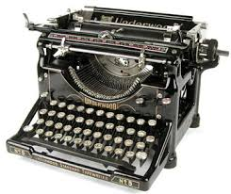

Notes: | need two

Prop # | 5
Prop Name: | Office desks
Prop Type: | Furniture
Script Location: | 1 | 1
Character: | Sternographer, Young woman
Quantity: | 2, possibly 3
Research Images: | 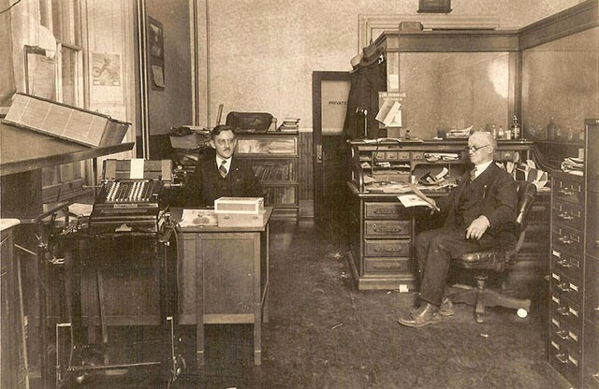

Notes: | two desks- one for sternographer, one for young woman. Possibly will need a third one for adding machine/adding clerk?

Prop # | 6
Prop Name: | Swivel chair
Prop Type: | Furniture
Script Location: | 2 | 1
Character: | Stenographer, young woman, telephone girl
Quantity: | At least 3- one for each desk and the switchboard
Research Images: | 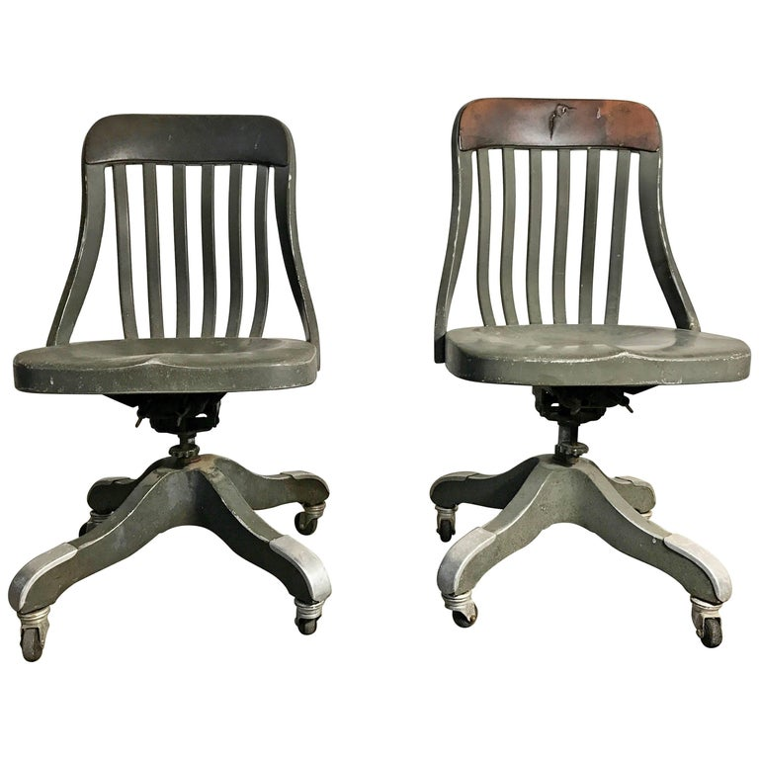

Notes:

Prop # | 7
Prop Name: | Files full of paper
Prop Type: | Hand Prop
Script Location: | 2 | 1
Character: | Filing Clerk
Quantity: | 1 for Filing clerk to handle, enough in the filing cabinet for the clerk to rifle through and file things
Research Images: | 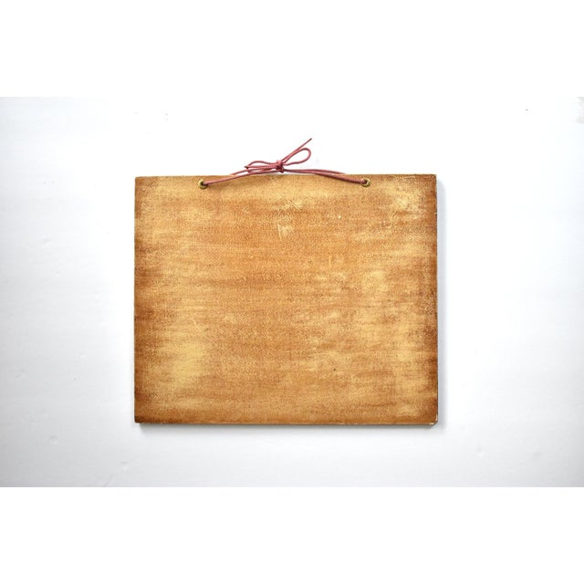

Notes:

Prop # | 8
Prop Name: | Letter
Prop Type: | Hand Prop
Script Location: | 2 | 1
Character: | Stenographer
Quantity: | 1
Research Images: | 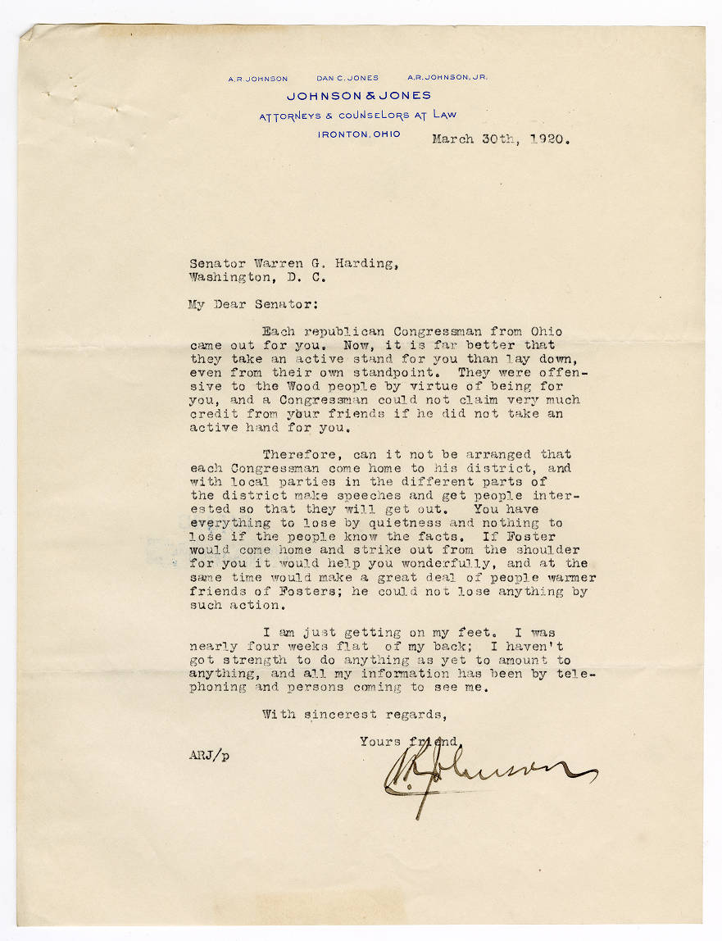

Notes:

Prop # | 9
Prop Name: | Memorandum
Prop Type: | Hand Prop
Script Location: | 3 | 1
Character: | Stenographer
Quantity: | 1
Research Images: | 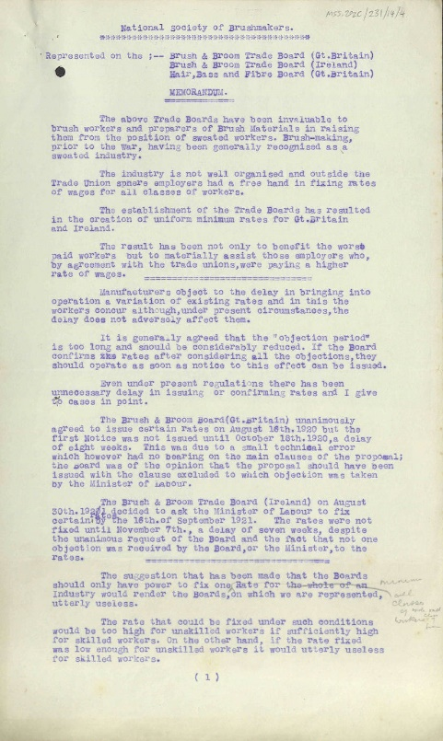

Notes: | Paper prop

Prop # | 10
Prop Name: | Director's meeting semi annual report card
Prop Type: | Hand Prop
Script Location: | 3 | 1
Character: | Stenographer
Quantity: | 1
Research Images: | 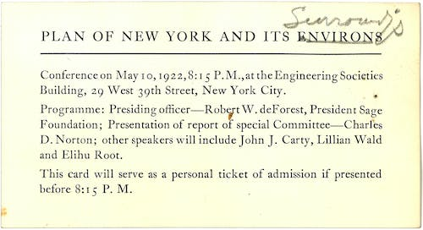

Notes: | paper prop

Prop # | 11
Prop Name: | Notepad and pen
Prop Type: | Hand Prop
Script Location: | 4 | 1
Character: | Telephone girl
Quantity: | 1
Research Images: | 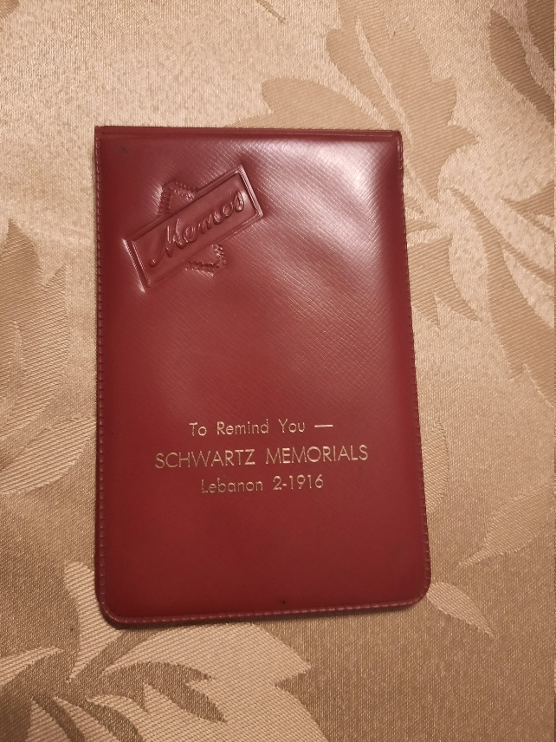

Notes:

Prop # | 12
Prop Name: | Mail
Prop Type: | Hand Prop
Script Location: | 9 | 1
Character: | Stenographer to Young Woman
Quantity: | 5 or so envelopes
Research Images: | 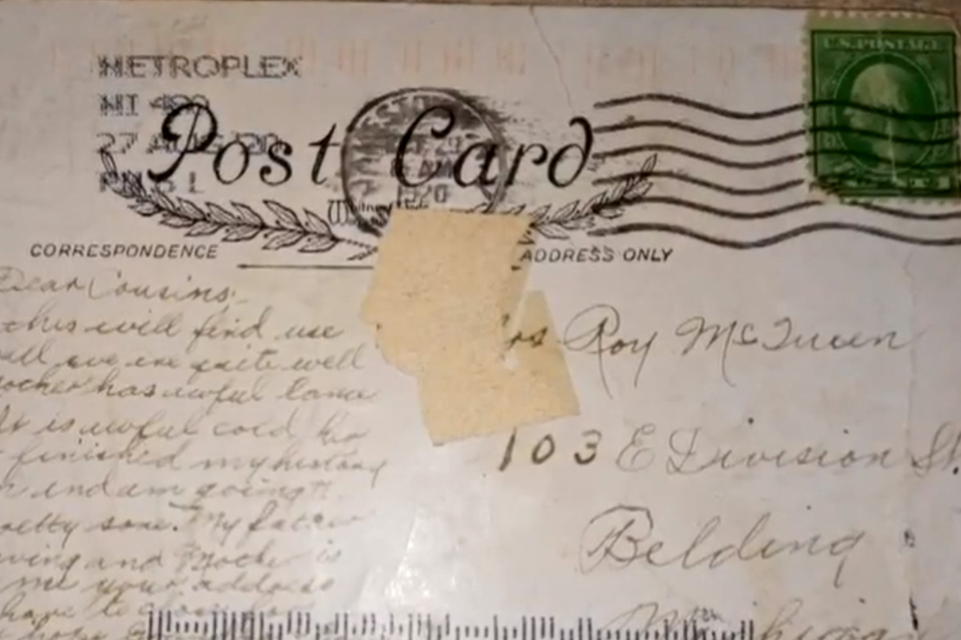

Notes: | Some should look more clean and official than others, some should be personal and distinctive

Prop # | 13
Prop Name: | Kitchen table
Prop Type: | Furniture
Script Location: | 13 | 2
Character: | Mother and young woman
Quantity: | 1
Research Images: | 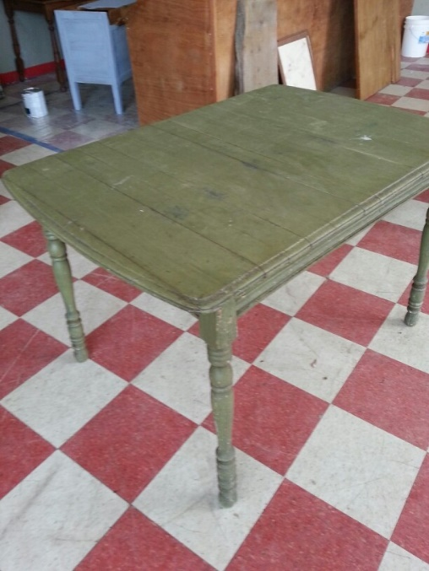

Notes: | small, old, and hostile-feeling

Prop # | 14
Prop Name: | Kitchen chair
Prop Type: | Furniture
Script Location: | 13 | 2
Character: | Mother and young woman
Quantity: | 2
Research Images: | 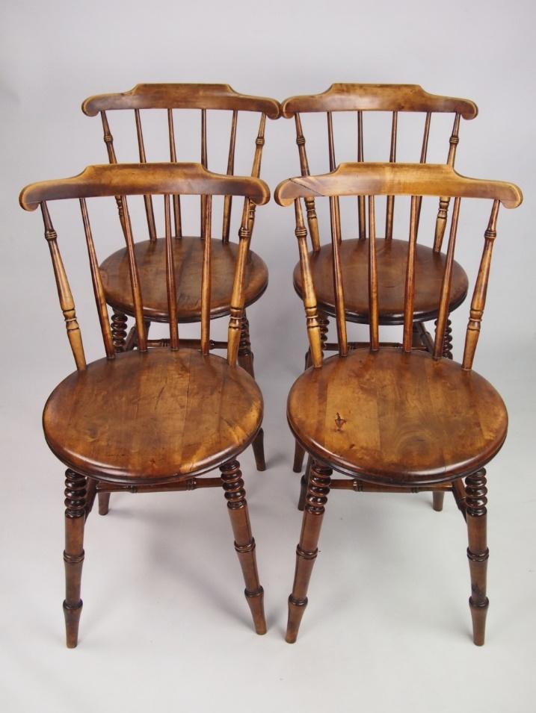

Notes:

Prop # | 15
Prop Name: | Dinner Plates
Prop Type: | Set Dressing
Script Location: | 13 | 2
Character: | Mother and Young Woman
Quantity: | 2
Research Images: | 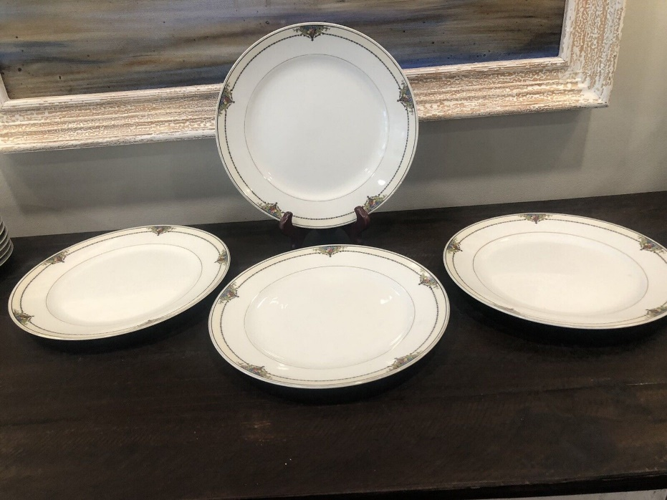

Notes: | simplistic, dated, even for the era

Prop # | 16
Prop Name: | Garbage Can
Prop Type: | Set Dressing
Script Location: | 13 | 2
Character: | Mother/Janitor
Quantity: | 1
Research Images: | 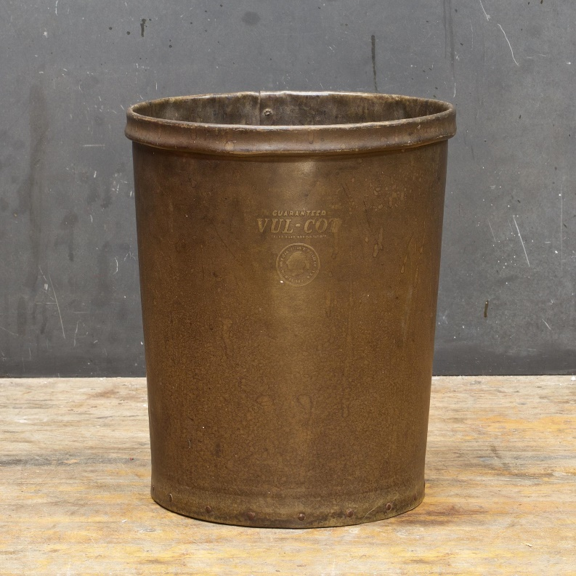

Notes: | solid metal, not mesh

Prop # | 17
Prop Name: | Rubber gloves
Prop Type: | Costume Prop
Script Location: | 13 | 2
Character: | Young Woman
Quantity: | 1 pair
Research Images: | 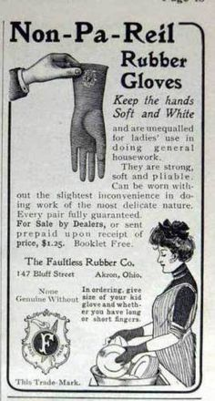

Notes: | Preferably green?

Prop # | 18
Prop Name: | Radio
Prop Type: | Set Dressing
Script Location: | 13 | 2
Character: | N/A
Quantity: | 1
Research Images: | 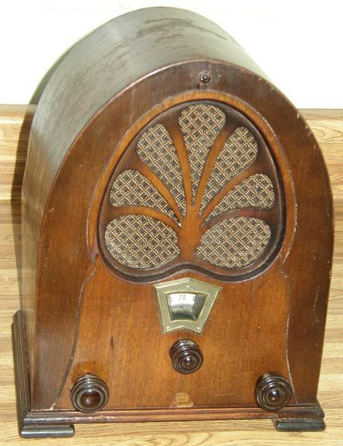

Notes:

Prop # | 19
Prop Name: | Flatware
Prop Type: | Hand Prop
Script Location: | 13 | 2
Character: | Mother and Young Woman
Quantity: | 2 sets
Research Images: | 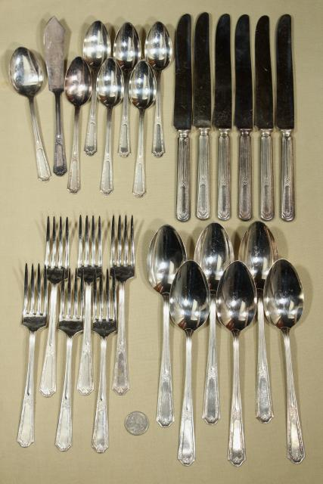

Notes:

Prop # | 20
Prop Name: | Potatoes
Prop Type: | Consumables
Script Location: | 13 | 2
Character: | Mother, young woman
Quantity: | 2
Research Images:

Notes:

Prop # | 21
Prop Name: | Stew in bowls
Prop Type: | Hand Prop
Script Location: | 13 | 2
Character: | Mother and Young woman
Quantity: | 2
Research Images: | 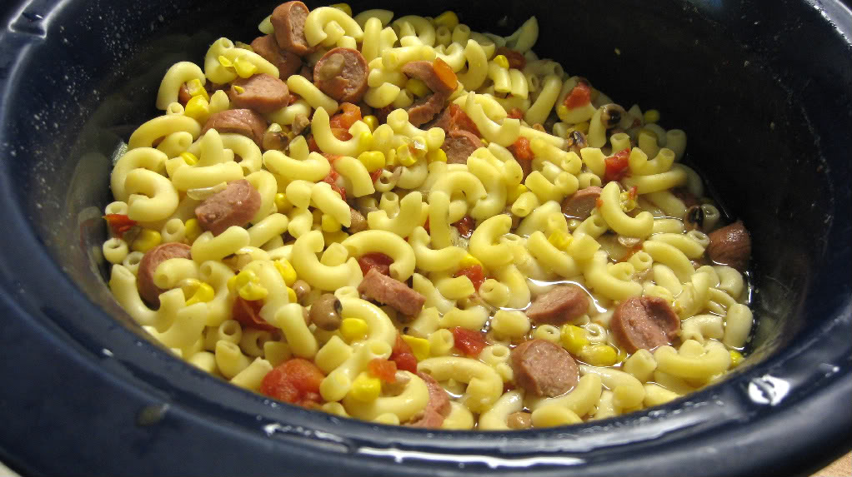

Notes: | not consumed, so could be faked

Prop # | 22
Prop Name: | Hotel bed
Prop Type: | Furniture
Script Location: | 21 | 3
Character: | Young Woman and Husband
Quantity: | 1
Research Images: | 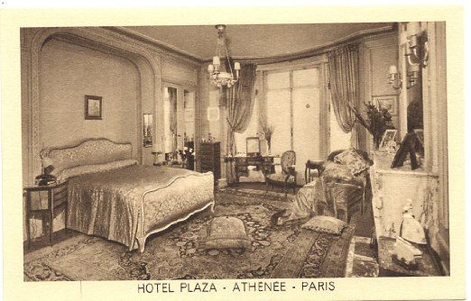

Notes: | Should be extravigant- hes pretty wealthy

Prop # | 23
Prop Name: | Chair
Prop Type: | Furniture
Script Location: | 21 | 3
Character: | Husband
Quantity: | 1
Research Images: | 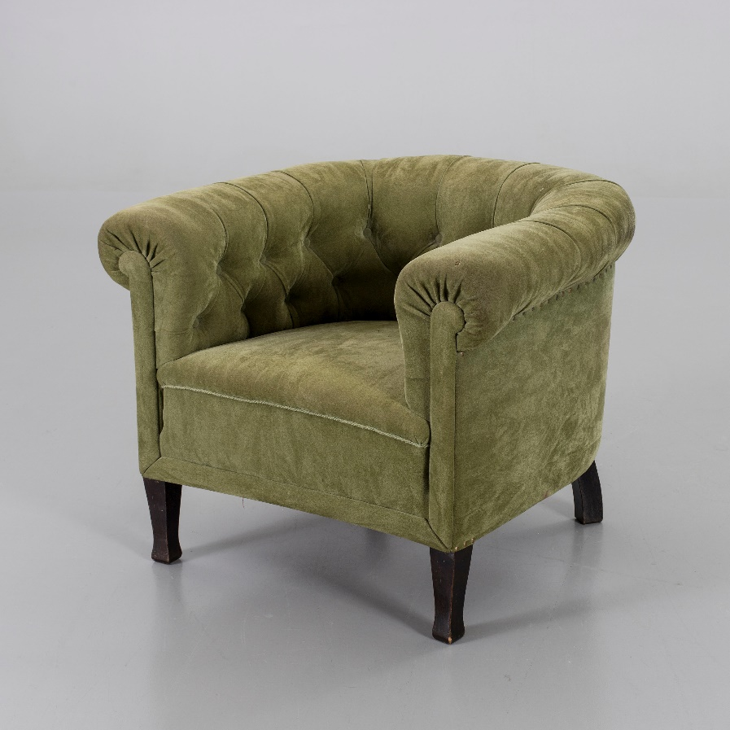

Notes:

Prop # | 24
Prop Name: | Mirror
Prop Type: | Set Dressing
Script Location: | 21 | 3
Character: | n/a
Quantity: | 1
Research Images: | 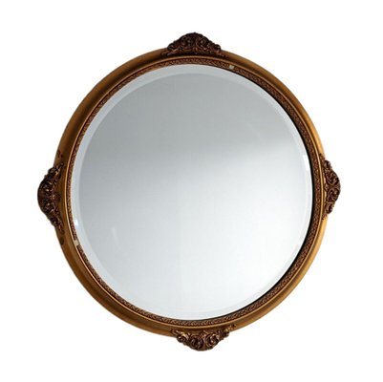

Notes:

Prop # | 25
Prop Name: | Luggage
Prop Type: | Hand Prop
Script Location: | 21 | 3
Character: | Young woman and Husband
Quantity: | 2
Research Images: | 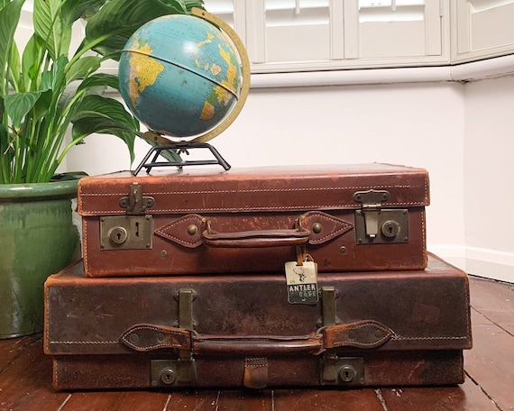

Notes:

Prop # | 26
Prop Name: | Tip
Prop Type: | Hand Prop
Script Location: | 21 | 3
Character: | Husband to Bellboy
Quantity: | 1
Research Images: | 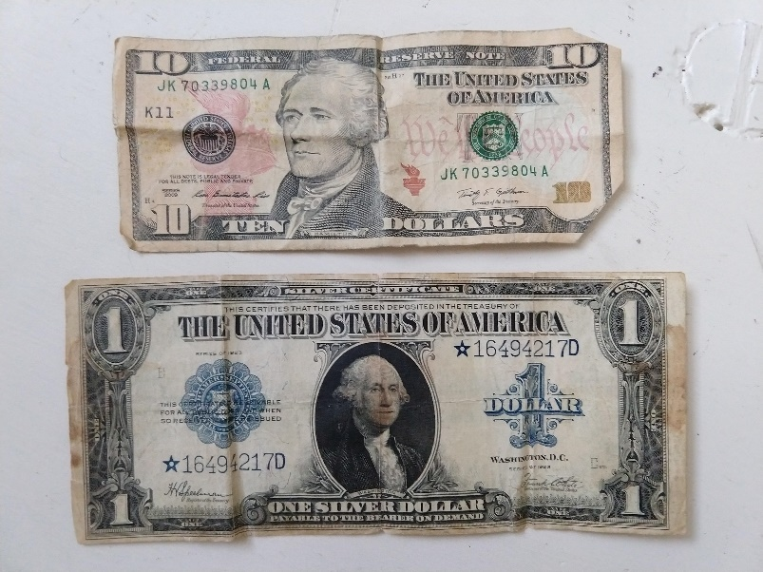

Notes: | Single bill

Prop # | 27
Prop Name: | Bedside table
Prop Type: | Set Dressing
Script Location: | 21 | 3
Character: | N/A
Quantity: | 1
Research Images: | 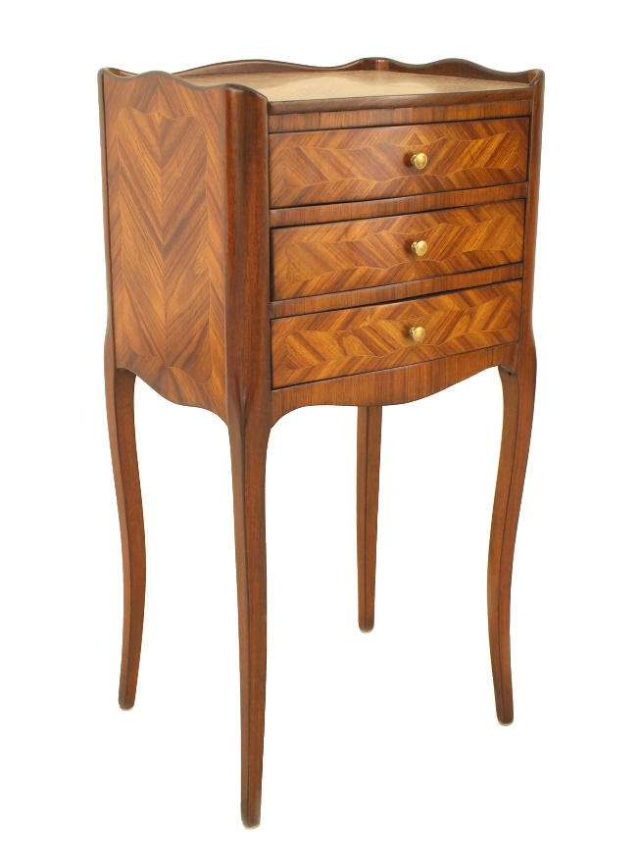

Notes:

Prop # | 28
Prop Name: | Hospital bed
Prop Type: | Furniture
Script Location: | 27 | 4
Character: | Young Woman
Quantity: | 1
Research Images: | 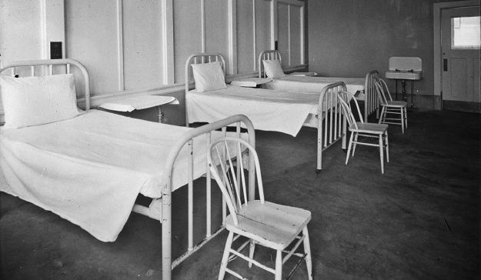

Notes:

Prop # | 29
Prop Name: | Chair
Prop Type: | Furniture
Script Location: | 27 | 4
Character: | N/A
Quantity: | 1
Research Images: | 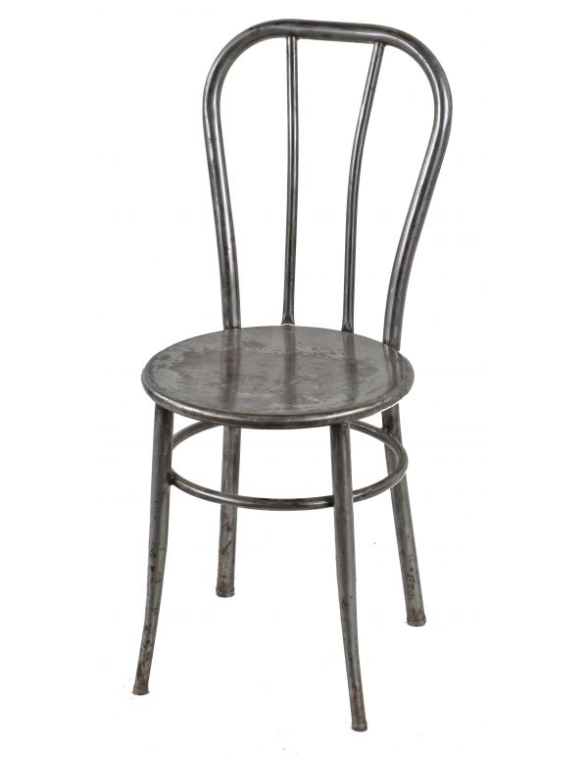

Notes:

Prop # | 30
Prop Name: | Chart
Prop Type: | Hand Prop
Script Location: | 27 | 4
Character: | Nurse
Quantity: | 1
Research Images: | 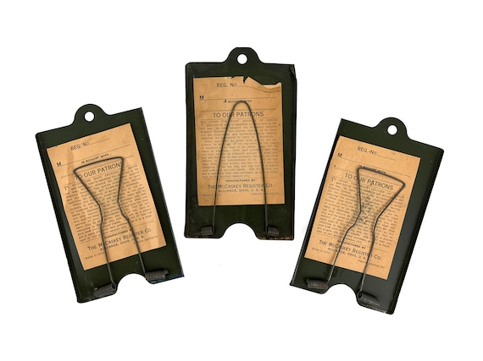

Notes: | Clipboard with papers and writing utensil

Prop # | 31
Prop Name: | Bouquet
Prop Type: | Hand Prop
Script Location: | 28 | 4
Character: | Husband
Quantity: | 1
Research Images: | 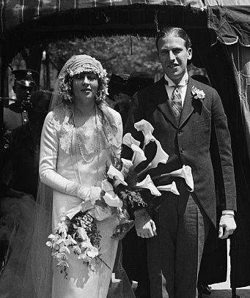

Notes:

Prop # | 32
Prop Name: | Vase
Prop Type: | Hand Prop
Script Location: | 28 | 4
Character: | Nurse
Quantity: | 1
Research Images: | 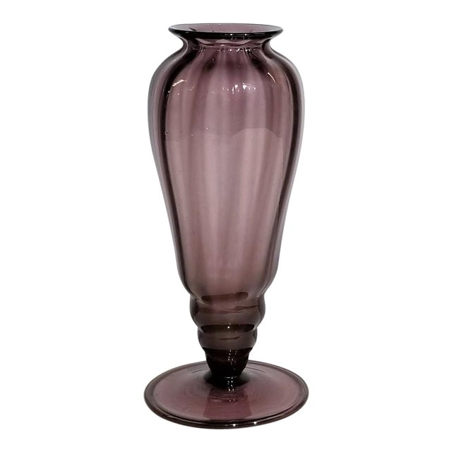

Notes: | Husband's bouquet gets put in vase by nurse

Prop # | 33
Prop Name: | Surgeon's wagon
Prop Type: | Furniture
Script Location: | 29 | 4
Character: | Doctor, Young Doctor, Nurse
Quantity: | 1
Research Images: | 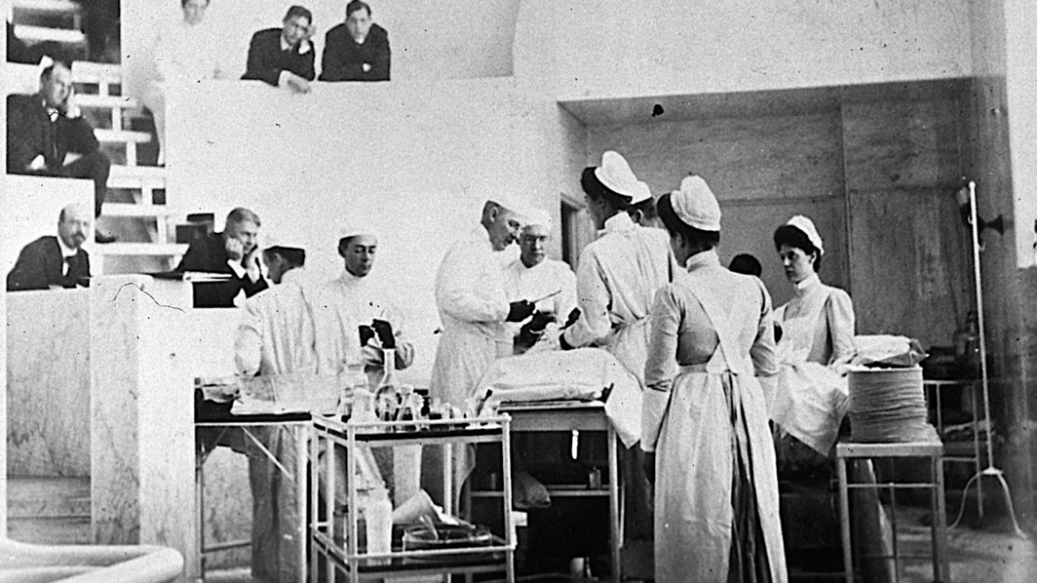

Notes: | Has to roll in

Prop # | 34
Prop Name: | Various Medical Instruments
Prop Type: | Set Dressing
Script Location: | 29 | 4
Character: | N/A
Quantity:
Research Images: | 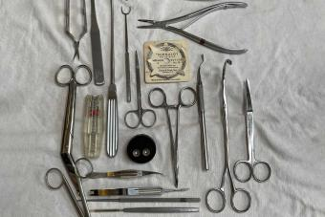

Notes: | Goes on surgeon's wagon

Prop # | 35
Prop Name: | Bottles
Prop Type: | Set Dressing
Script Location: | 29 | 4
Character: | N/A
Quantity:
Research Images: | 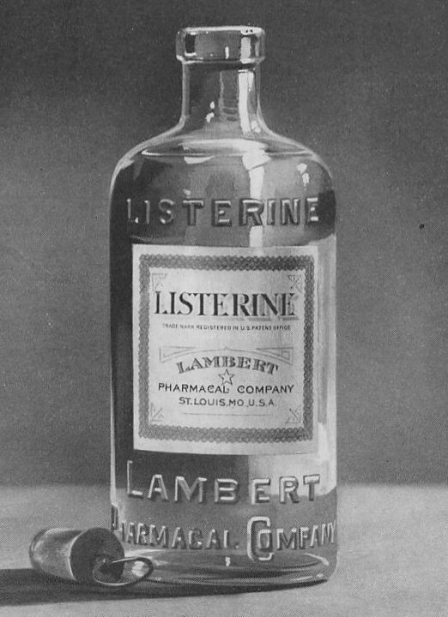

Notes: | Goes on surgeons wagon

Prop # | 36
Prop Name: | Paper Pad and pen
Prop Type: | Hand Prop
Script Location: | 30 | 4
Character: | Doctor
Quantity: | 1
Research Images: | 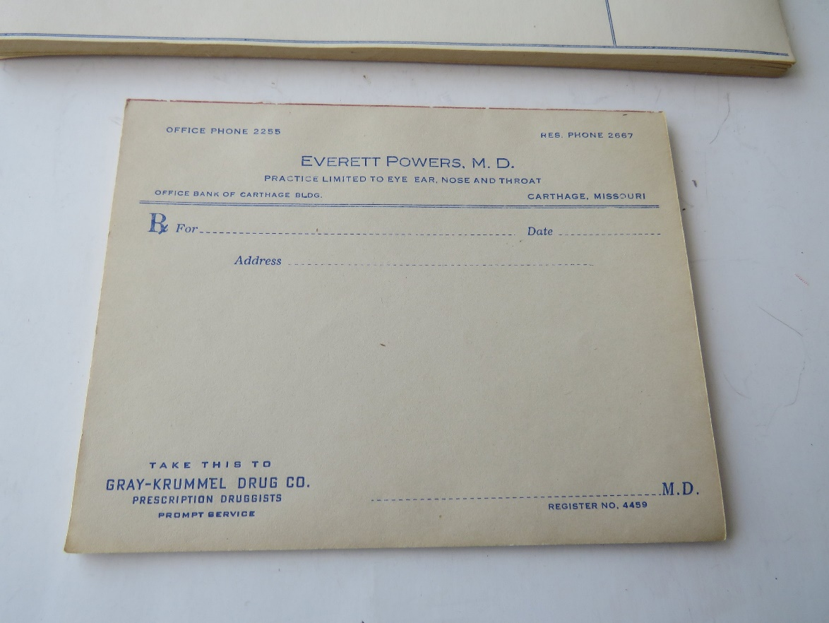

Notes:

Prop # | 37
Prop Name: | Bar
Prop Type: | Furniture
Script Location: | 31 | 5
Character: | Man, Policeman
Quantity: | 1
Research Images: | 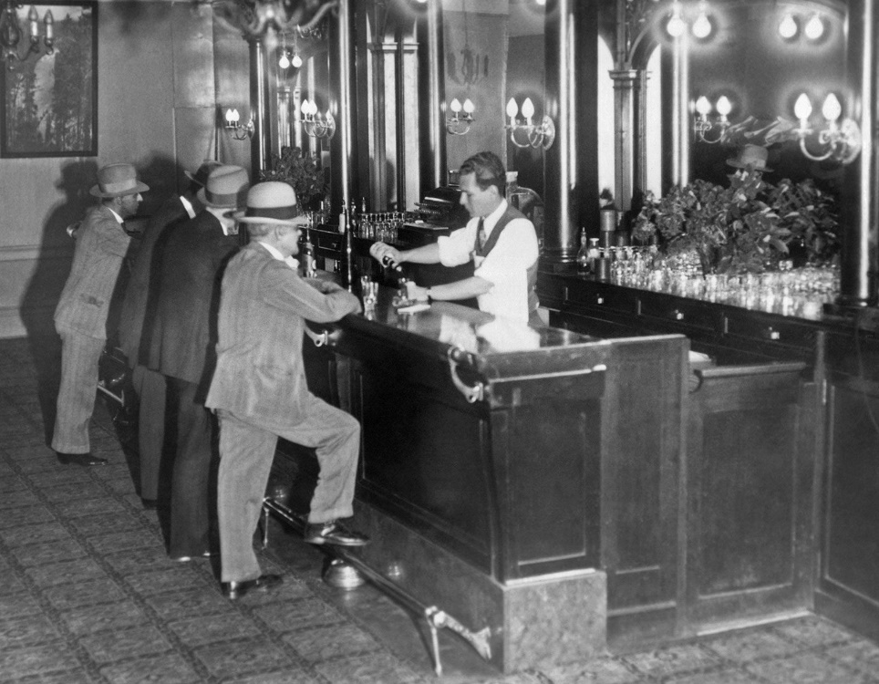

Notes:

Prop # | 38
Prop Name: | Bottles
Prop Type: | Set Dressing
Script Location: | 32 | 5
Character: | Man behind bar
Quantity:
Research Images: | 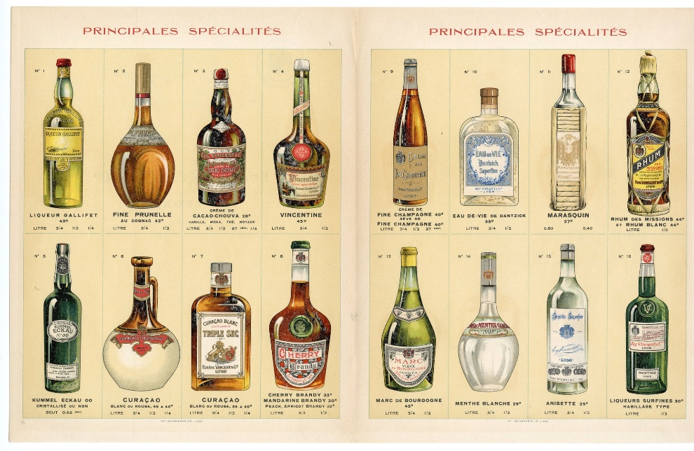

Notes: | Straight pour drinks

Prop # | 39
Prop Name: | Tables
Prop Type: | Furniture
Script Location: | 32 | 5
Character: | Man and woman, Man and boy, Two Men
Quantity: | 3
Research Images: | 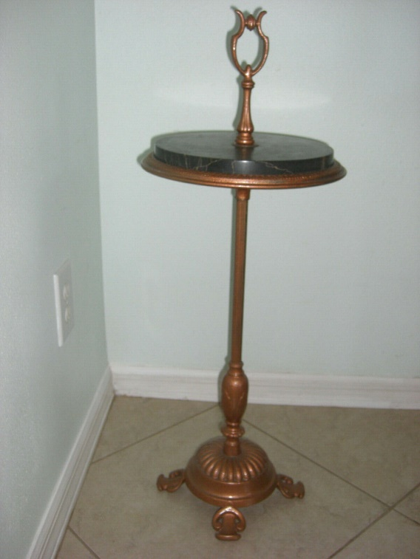

Notes:

Prop # | 42
Prop Name: | Drink glasses
Prop Type: | Hand Prop
Script Location: | 32 | 5
Character: | First Man, Second Man, Man, Woman
Quantity: | 4
Research Images: | 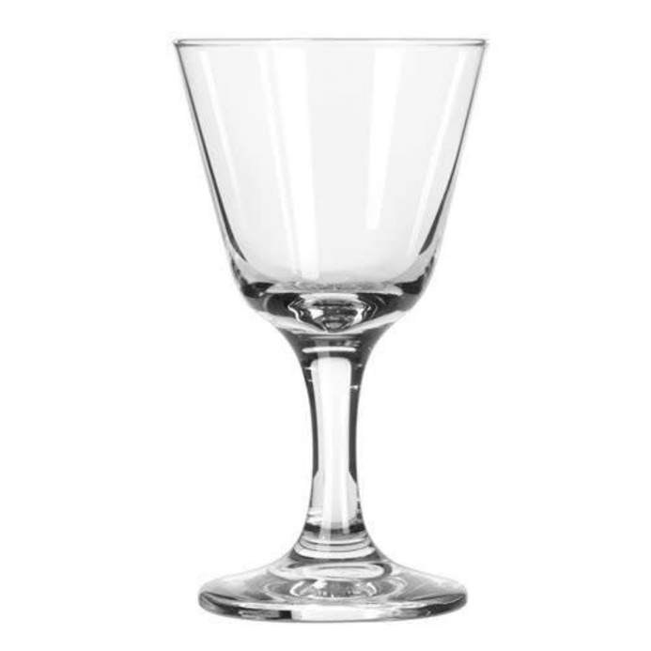

Notes: | Manhattan Style

Prop # | 43
Prop Name: | Wine Glasses
Prop Type: | Hand Prop
Script Location: | 33 | 5
Character: | Man, boy
Quantity: | 2
Research Images: | 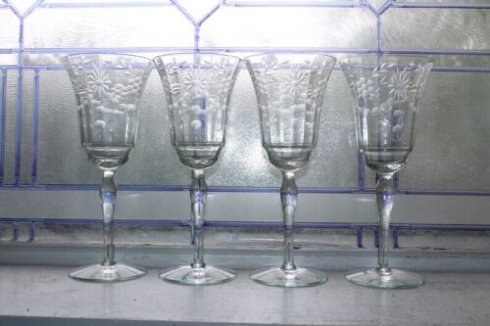

Notes:

Prop # | 44
Prop Name: | Cigarette Packages
Prop Type: | Hand Prop
Script Location: | 35 | 5
Character: | First and Second Man
Quantity: | 2
Research Images: | 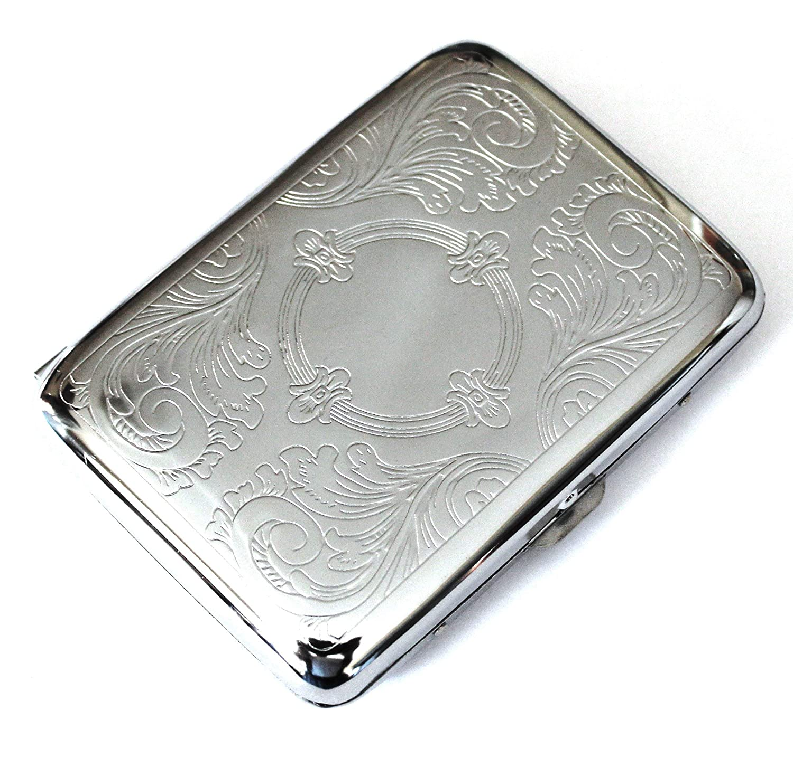

Notes:

Prop # | 45
Prop Name: | Cigarettes
Prop Type: | Hand Prop
Script Location: | 35 | 5,6
Character: | Girl, Young woman, second man
Quantity: | 3
Research Images: | 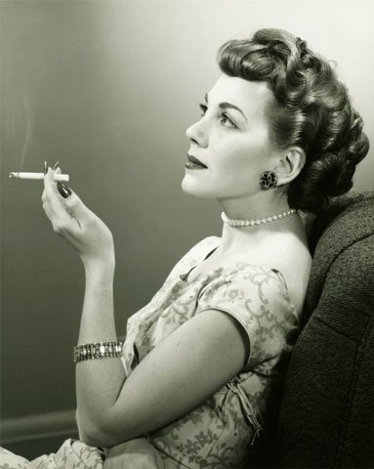

Notes: | 3 in a box, like to be lit/with smoke

Prop # | 46
Prop Name: | Coin
Prop Type: | Hand Prop
Script Location: | 37 | 1
Character: | Second man
Quantity: | 1
Research Images: | 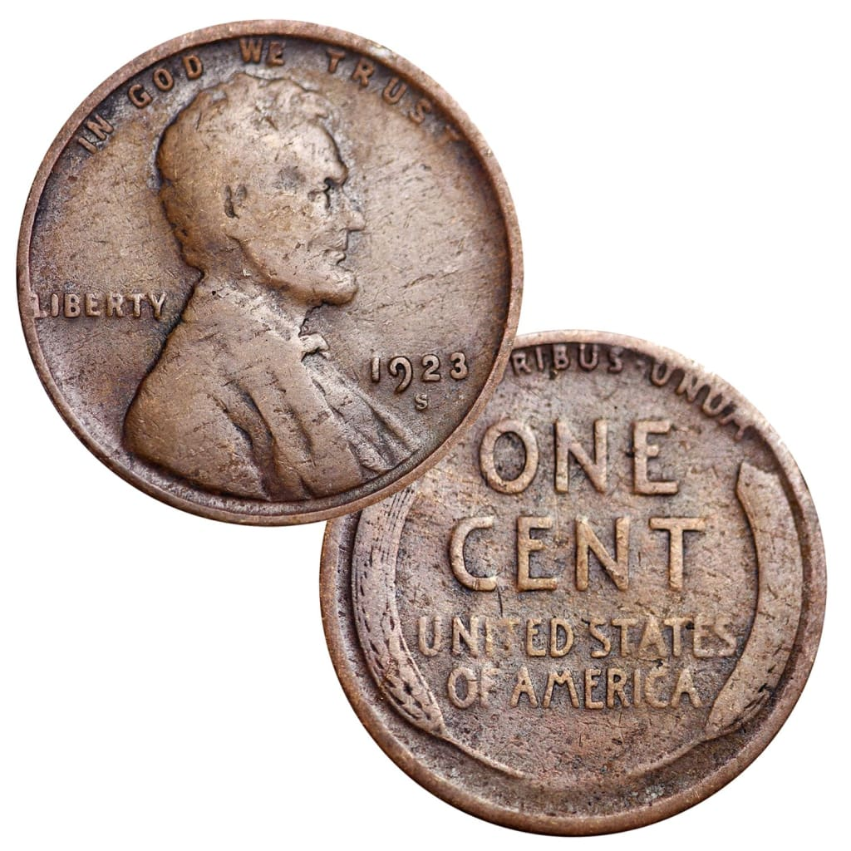

Notes:

Prop # | 47
Prop Name: | Small card and Pen
Prop Type: | Hand Prop
Script Location: | 39 | 5
Character: | Second Man
Quantity: | 1
Research Images: | 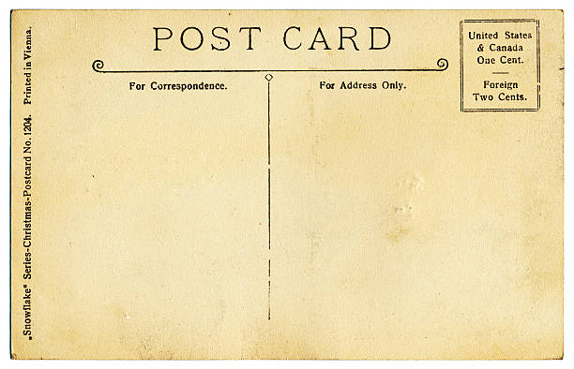

Notes:

Prop # | 48
Prop Name: | Bottle
Prop Type: | Hand Prop
Script Location: | 41 | 5
Character: | Young Woman
Quantity: | 1
Research Images: | 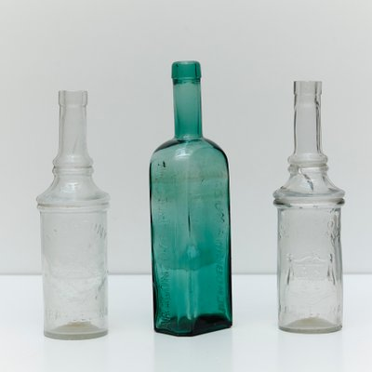

Notes:

Prop # | 49
Prop Name: | Wrapped bottle
Prop Type: | Hand Prop
Script Location: | 44 | 5
Character: | First man
Quantity: | 1
Research Images: | 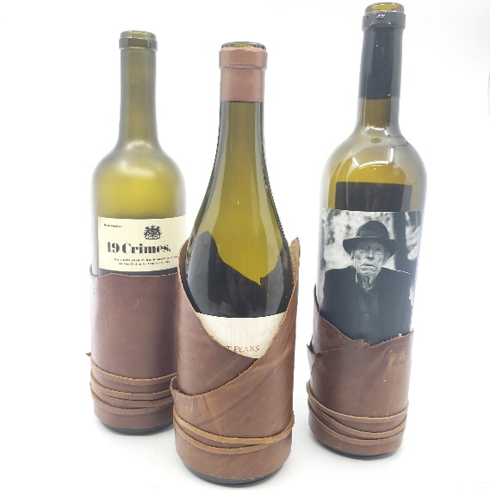

Notes:

Prop # | 50
Prop Name: | Nickel
Prop Type: | Hand Prop
Script Location: | 44 | 5
Character: | First Man
Quantity: | 1
Research Images: | 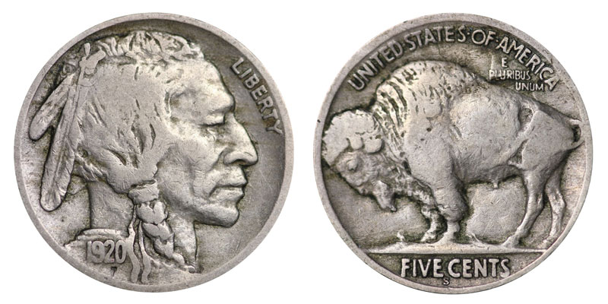

Notes:

Prop # | 51
Prop Name: | Bed
Prop Type: | Furniture
Script Location: | 45 | 6
Character: | Man, Young woman
Quantity: | 1
Research Images: | 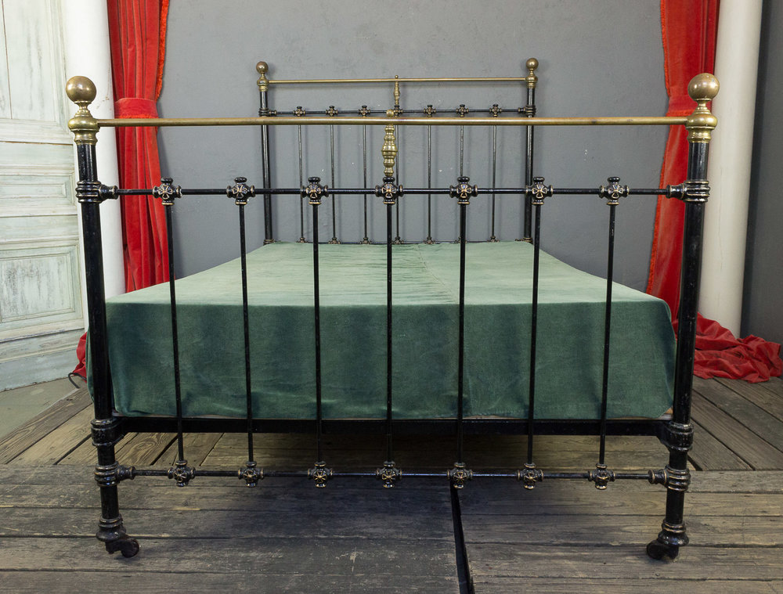

Notes:

Prop # | 52
Prop Name: | Match
Prop Type: | Hand Prop
Script Location: | 45 | 6
Character: | Man
Quantity: | 1
Research Images: | 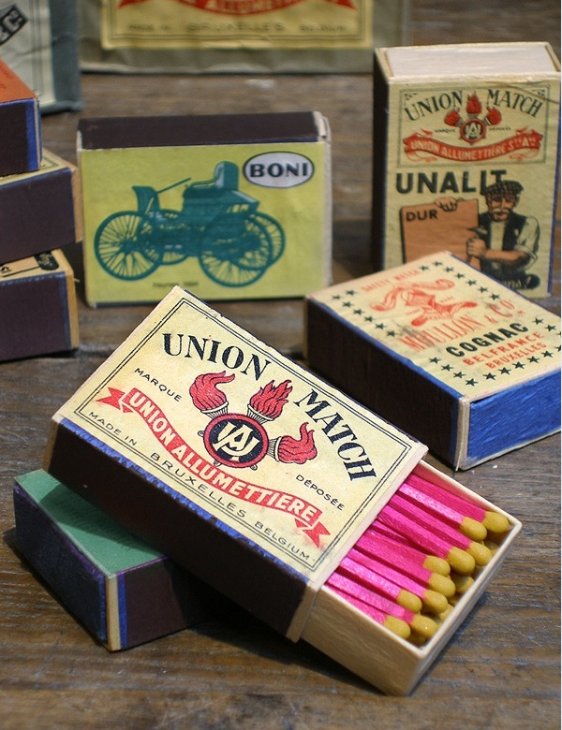

Notes:

Prop # | 53
Prop Name: | Lily in a bowl with rocks and water
Prop Type: | Hand Prop
Script Location: | 49 | 6
Character: | Woman
Quantity: | 1
Research Images: | 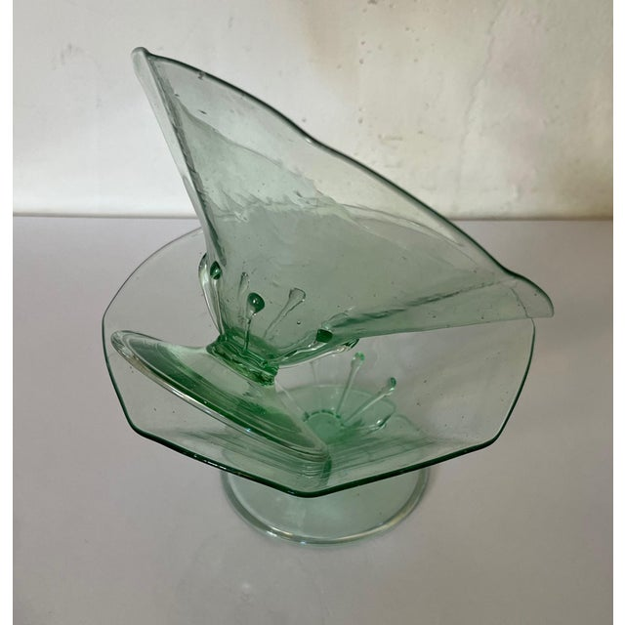

Notes:

Prop # | 54
Prop Name: | Dresser
Prop Type: | Furniture
Script Location: | 51 | 6
Character: | N/A
Quantity: | 1
Research Images: | 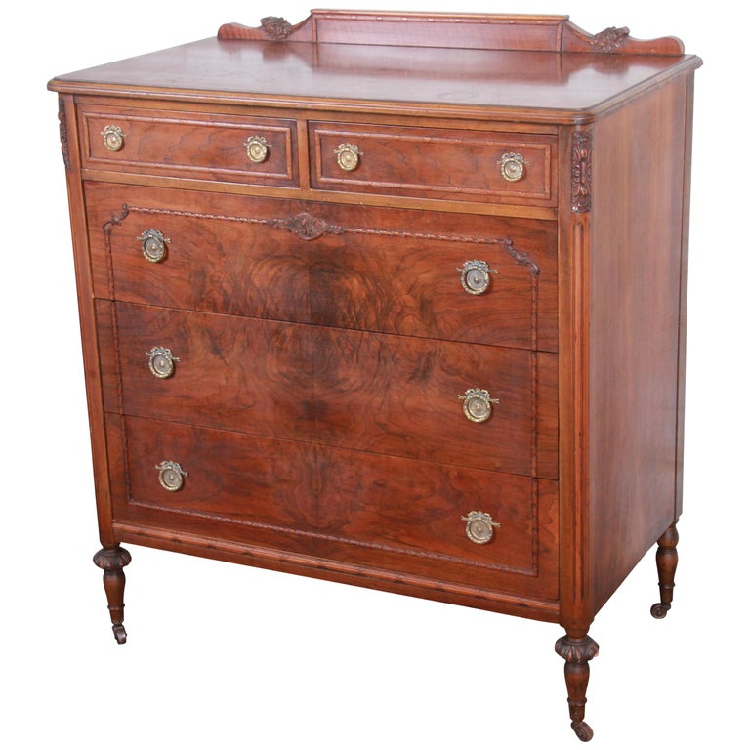

Notes:

Prop # | 55
Prop Name: | Mirror
Prop Type: | Furniture
Script Location: | 51 | 6
Character: | N/A
Quantity: | 1
Research Images: | 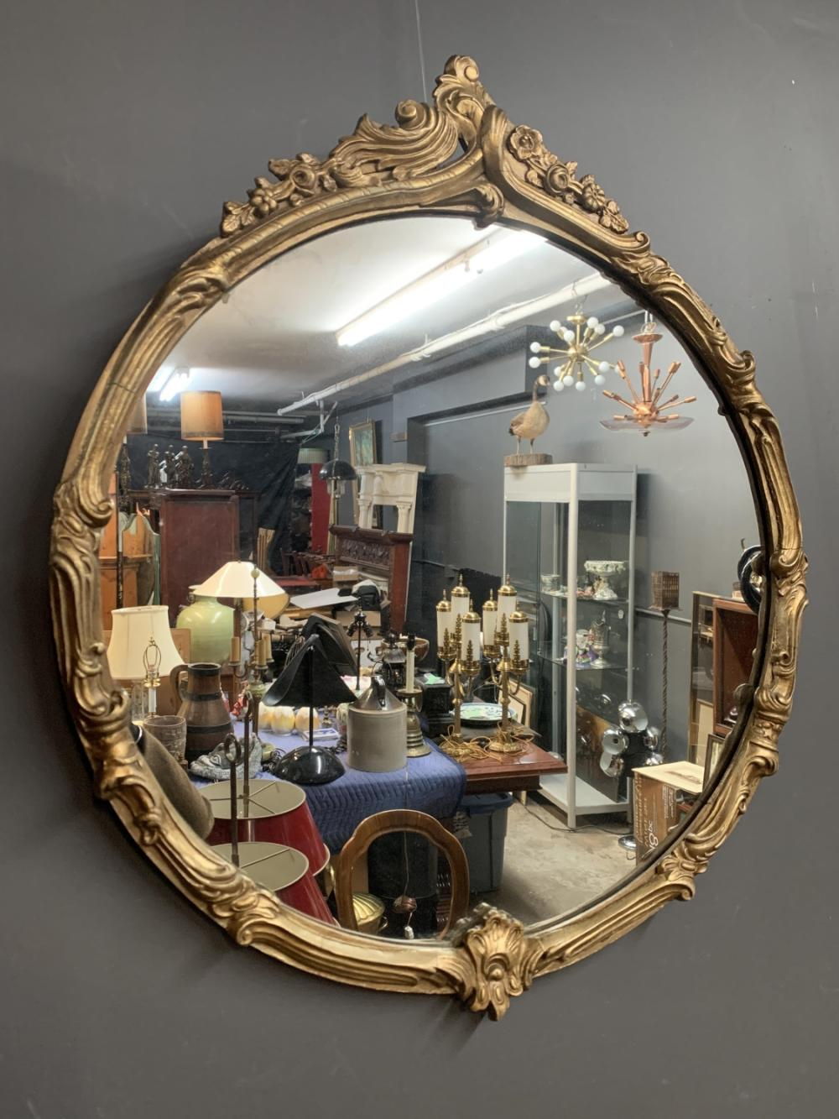

Notes:

Prop # | 56
Prop Name: | Divan
Prop Type: | Furniture
Script Location: | 53 | 7
Character: | Young Woman, Husband
Quantity: | 1
Research Images: | 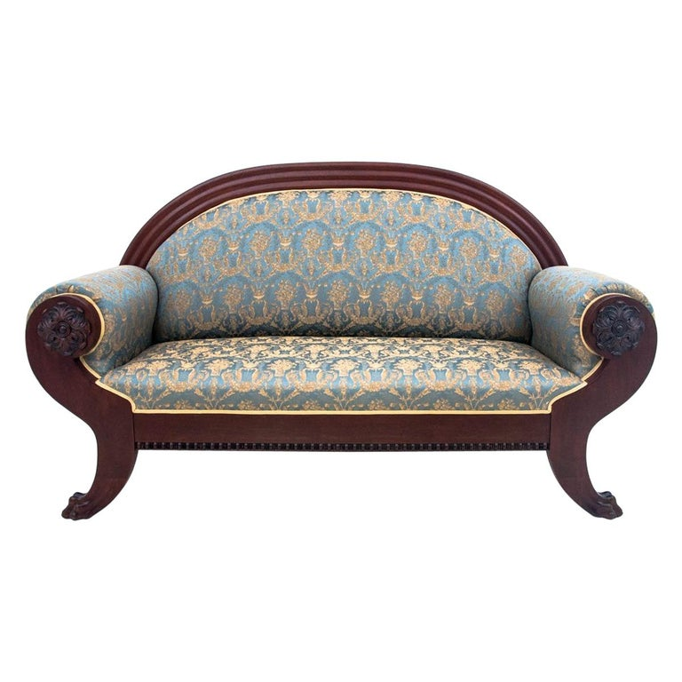

Notes:

Prop # | 57
Prop Name: | Telephone
Prop Type: | Hand Prop
Script Location: | 53 | 7
Character: | Husband
Quantity: | 1
Research Images: | 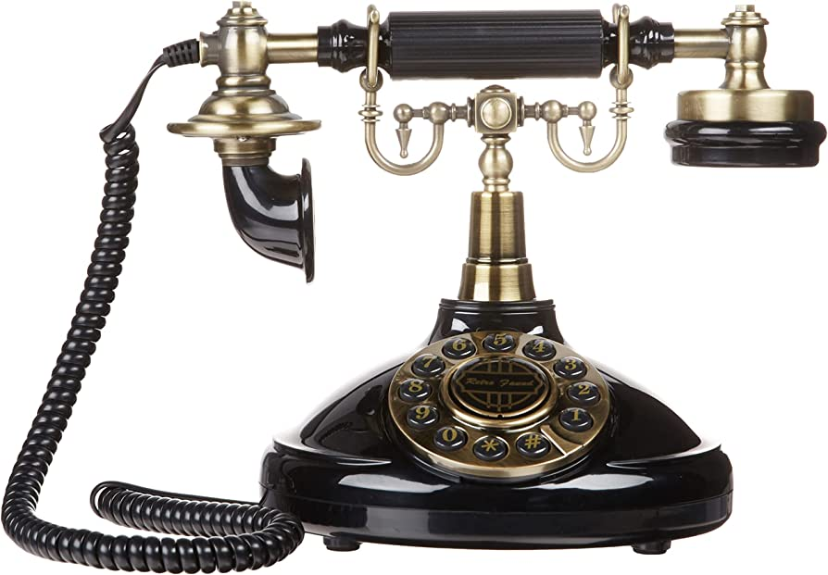

Notes:

Prop # | 58
Prop Name: | Side Table
Prop Type: | Set Dressing
Script Location: | 53 | 7
Character: | N/A
Quantity: | 1
Research Images: | 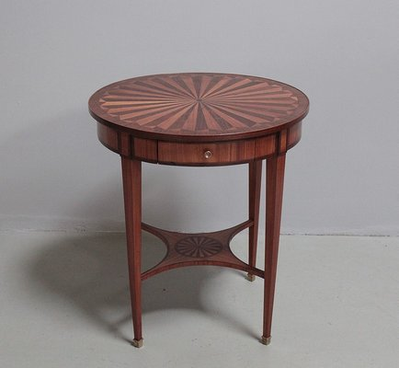

Notes: | For the telephone

Prop # | 59
Prop Name: | Newspapers
Prop Type: | Hand Prop
Script Location: | 53 | 7
Character: | Young Woman, Husband
Quantity: | 2
Research Images: | 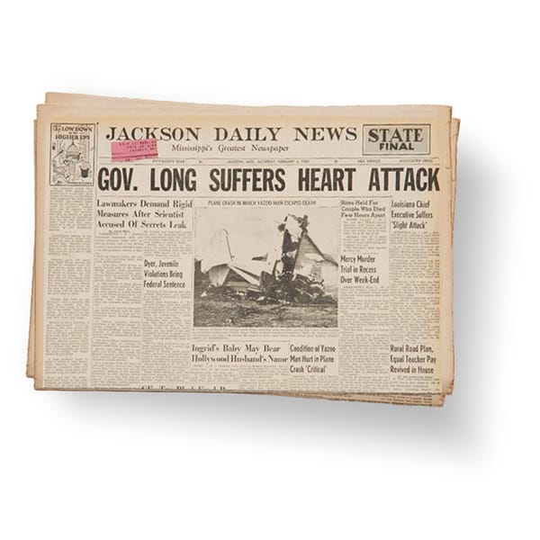

Notes:

Prop # | 62
Prop Name: | Case files
Prop Type: | Hand Prop
Script Location: | 60 | 8
Character: | Law Clerks
Quantity: | 3
Research Images: | 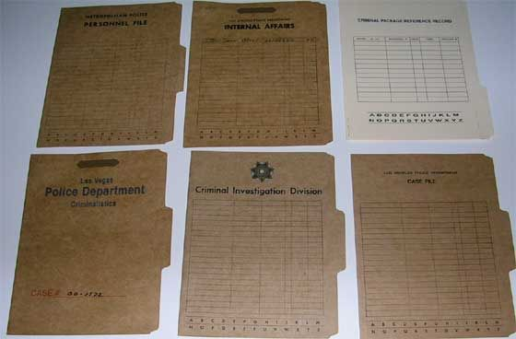

Notes:

Prop # | 63
Prop Name: | Reporters' notepads
Prop Type: | Hand Prop
Script Location: | 61 | 8
Character: | Reporters
Quantity: | 3
Research Images: | 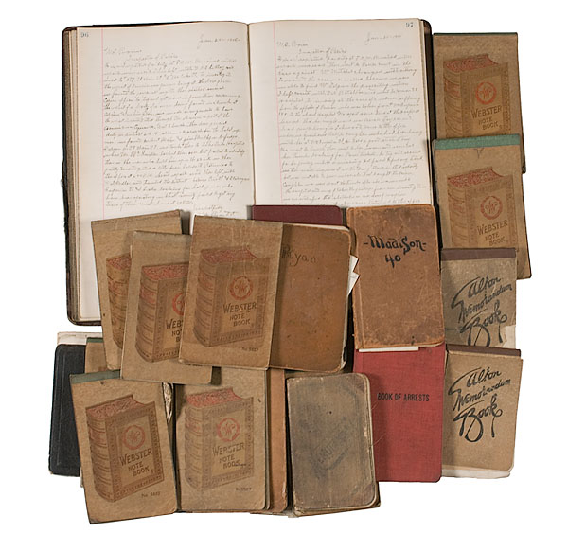

Notes:

Prop # | 64
Prop Name: | Briefcases
Prop Type: | Hand Prop
Script Location: | 61 | 8
Character: | Laywers
Quantity: | 2
Research Images: | 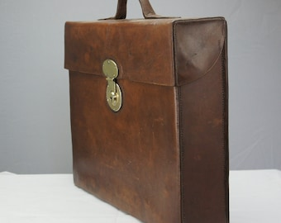

Notes:

Prop # | 65
Prop Name: | Bible
Prop Type: | Hand Prop
Script Location: | 61 | 8
Character: | Bailiff
Quantity: | 1
Research Images: | 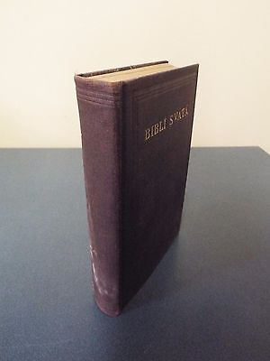

Notes:

Prop # | 66
Prop Name: | Paper with Helen's address
Prop Type: | Hand Prop
Script Location: | 61 | 8
Character: | Laywer for defense
Quantity: | 1
Research Images: | 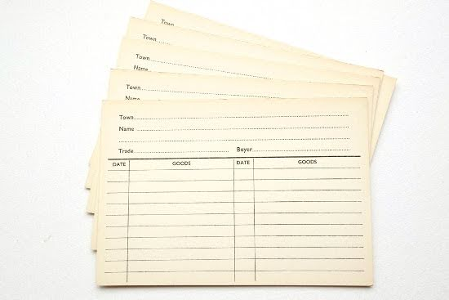

Notes:

Prop # | 68
Prop Name: | Defendant/prosecutor's chairs
Prop Type: | Furniture
Script Location: | 60 | 8
Character: | Lawyers, young woman
Quantity: | 3
Research Images: | 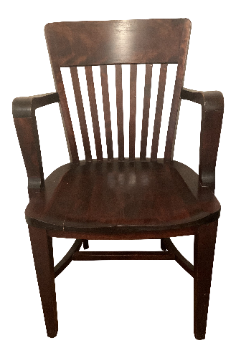

Notes:

Prop # | 69
Prop Name: | Broken bottle neck (evidence)
Prop Type: | Hand Prop
Script Location: | 69 | 8
Character: | Lawyer for prosecution
Quantity: | 1
Research Images: | 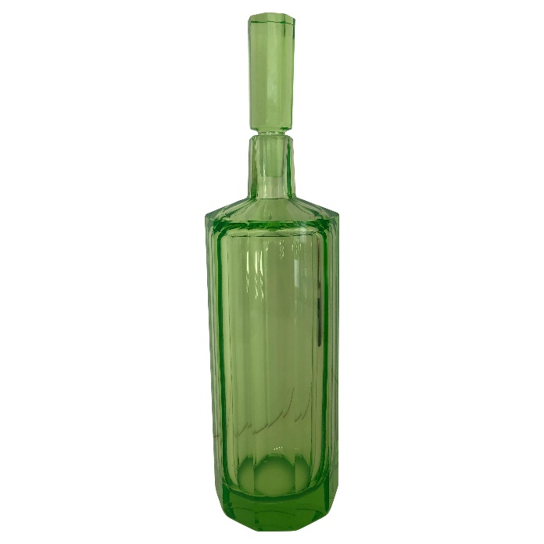

Notes: | Broken bottle neck, shards of glass, and pebbles from lily inside bag

Prop # | 70
Prop Name: | Gloves (evidence)
Prop Type: | Hand Prop
Script Location: | 70 | 8
Character: | Lawyer for Prosecution
Quantity: | 1
Research Images: | 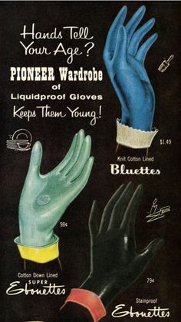

Notes:

Prop # | 71
Prop Name: | Nightgown (evidence)
Prop Type: | Hand Prop
Script Location: | 70 | 8
Character: | Lawyer for prosecution
Quantity: | 1
Research Images: | 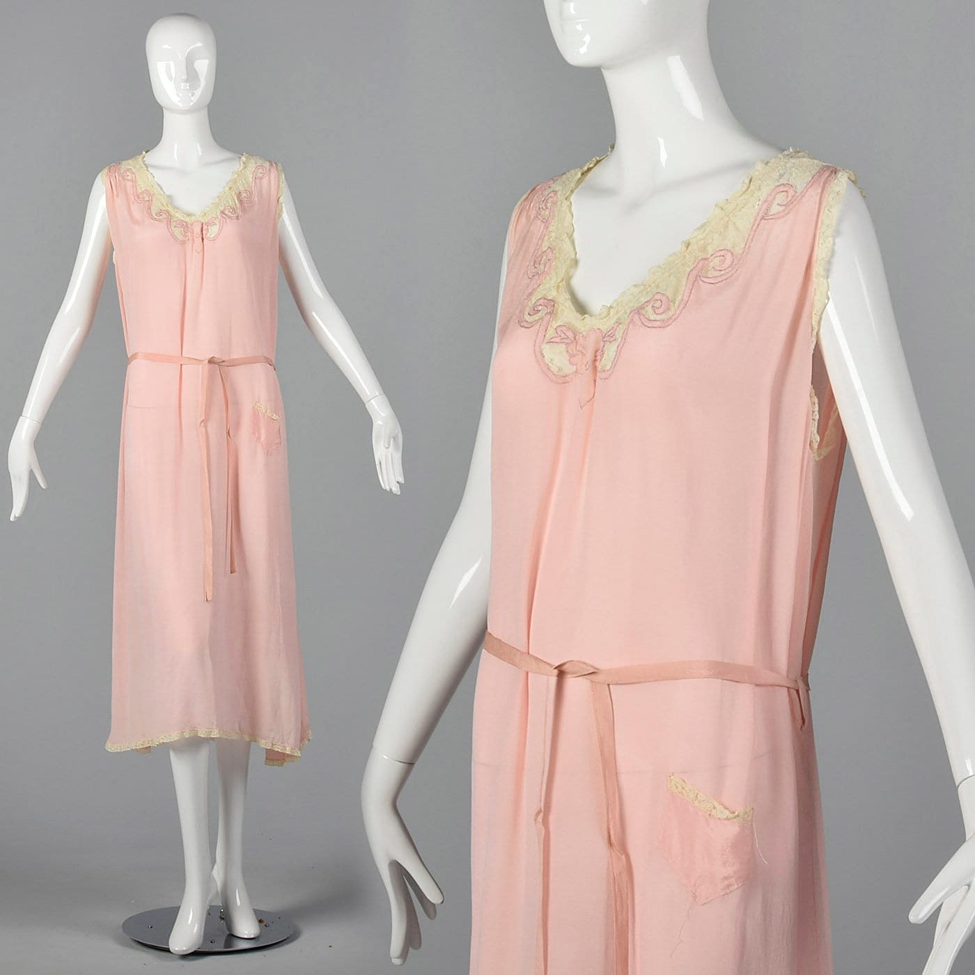

Notes: | Bloodied?

Prop # | 72
Prop Name: | Lily bowl (evidence)
Prop Type: | Hand Prop
Script Location: | 72 | 8
Character: | Lawyer for prosecution
Quantity: | 1
Research Images: | 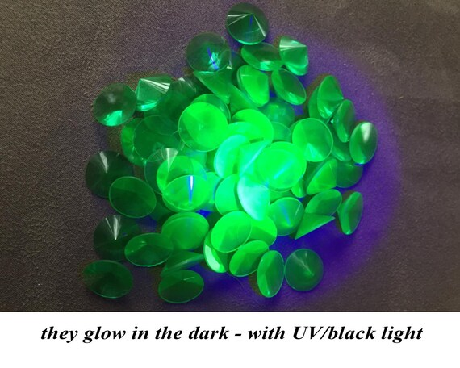

Notes:

Prop # | 73
Prop Name: | Various papers
Prop Type: | Hand Prop
Script Location: | 73 | 8
Character: | Lawyer for prosecution
Quantity:
Research Images: | 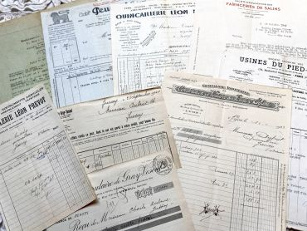

Notes:

Prop # | 74
Prop Name: | Affadavit
Prop Type: | Hand Prop
Script Location: | 73 | 8
Character: | Lawyer for prosecution
Quantity: | 1
Research Images: | 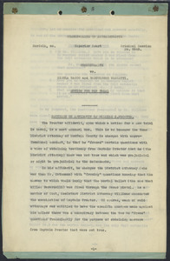

Notes:

Prop # | 75
Prop Name: | Jail chairs
Prop Type: | Furniture
Script Location: | 77 | 9
Character: | Jailer and Matron
Quantity: | 3
Research Images: | 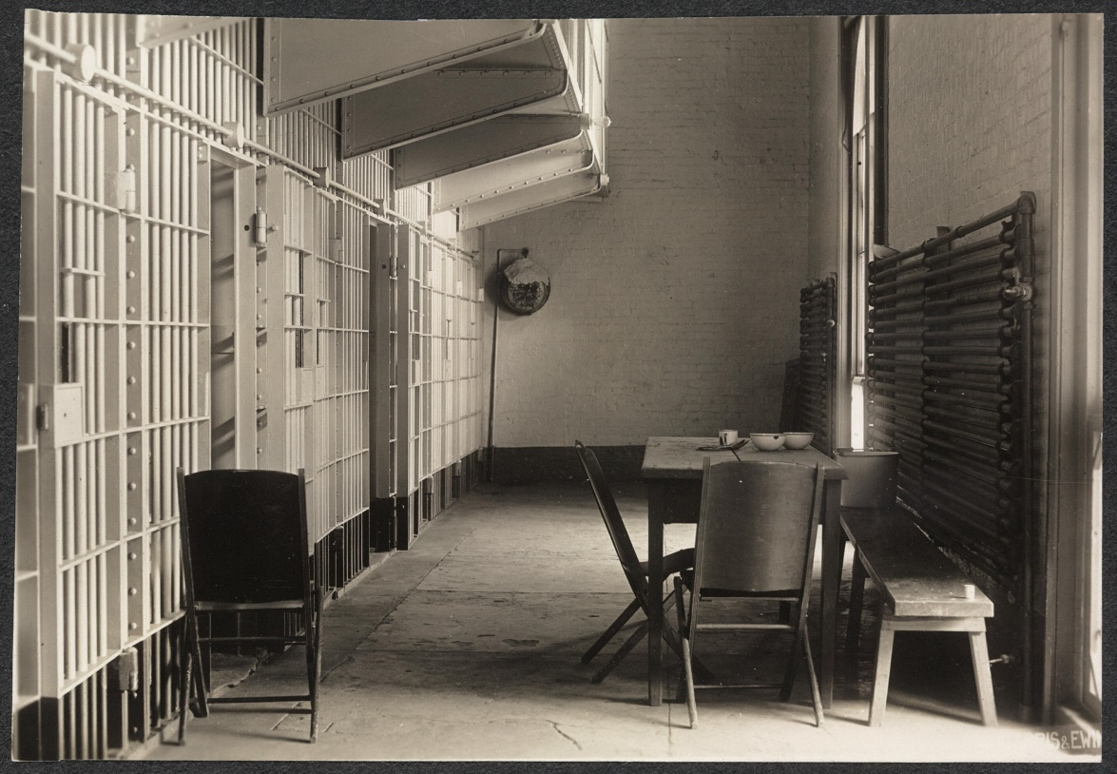

Notes:

Prop # | 76
Prop Name: | Keys
Prop Type: | Hand Prop
Script Location: | 78 | 9
Character: | Jailer
Quantity: | 1
Research Images: | 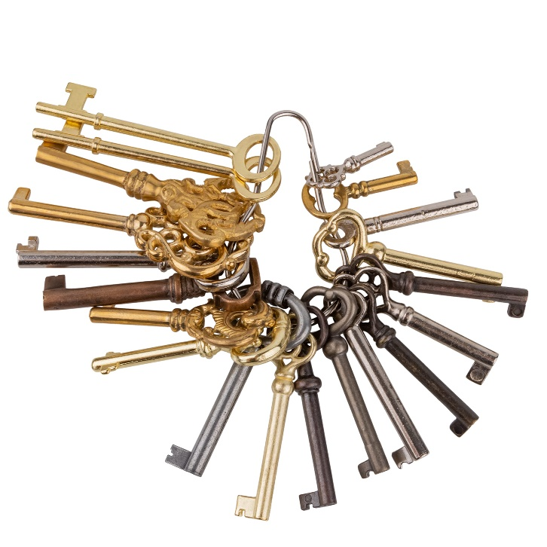

Notes:

Prop # | 77
Prop Name: | Scissors/razor
Prop Type: | Hand Prop
Script Location: | 78 | 9
Character: | Barber
Quantity: | 1
Research Images: | 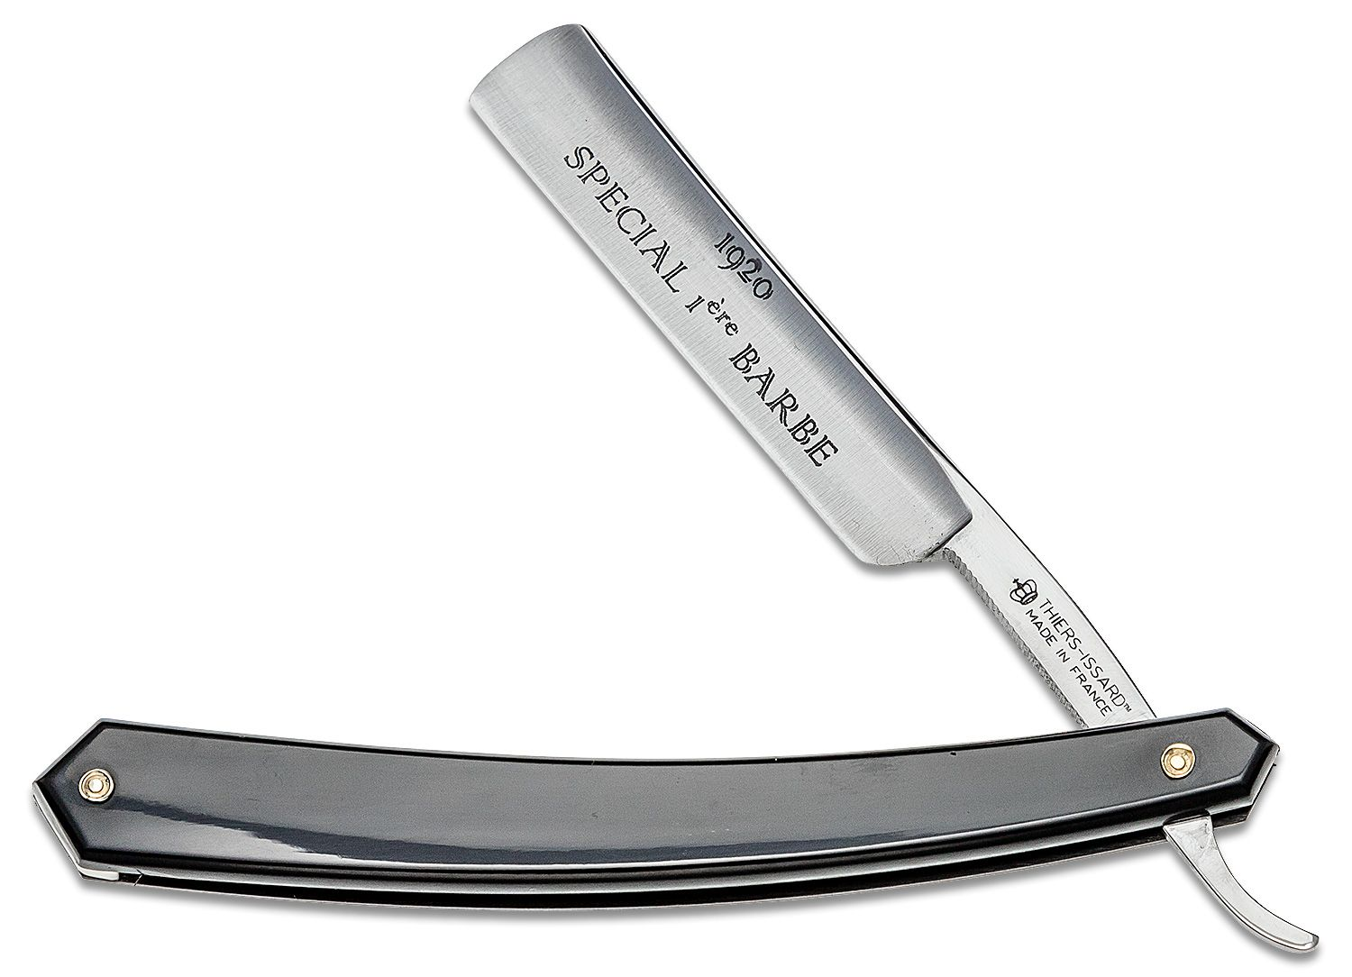

Notes:

Prop # | 78
Prop Name: | Lock of hair
Prop Type: | hand prop
Script Location: | 78 | 9
Character: | barber
Quantity: | 1
Research Images:

Notes:

Prop # | 79
Prop Name: | Glass of water
Prop Type: | Hand Prop
Script Location: | 13 | 2
Character: | Young Woman
Quantity: | 1
Research Images: | 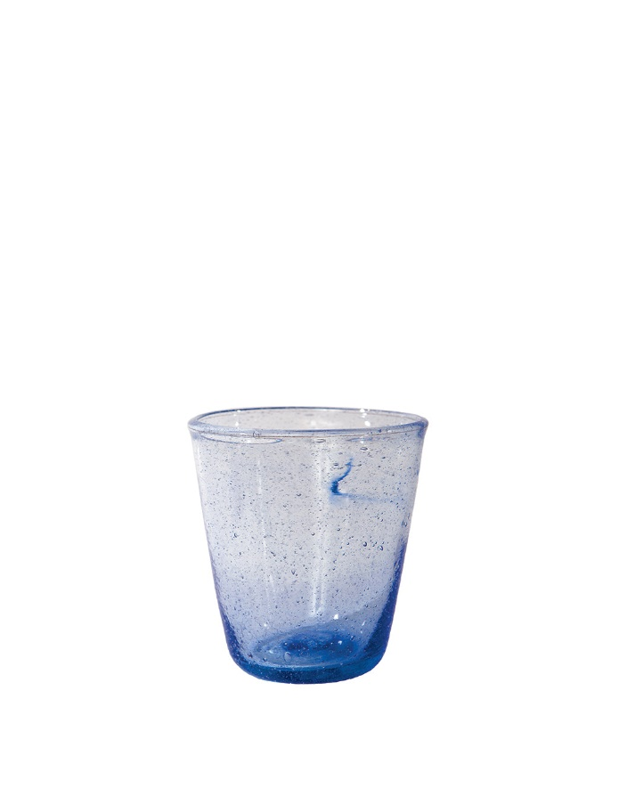

Notes: | ADD

Prop # | 80
Prop Name: | Phone
Prop Type: | Hand prop
Script Location: | 1 | 1
Character: | Mr. Jones
Quantity: | 1
Research Images: | 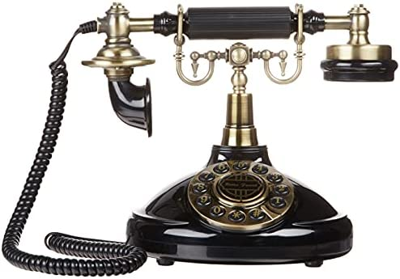

Notes: | ADD

Prop # | 81
Prop Name: | Box for evidence
Prop Type: | Hand prop
Script Location: | 62 | 8
Character: | Bailiff
Quantity: | 1
Research Images: | 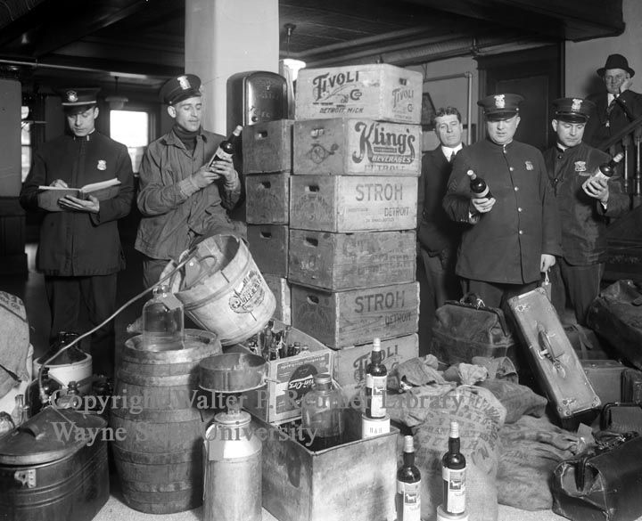

Notes: | ADD

Prop # | 82
Prop Name: | Pencils
Prop Type: | Hand Prop
Script Location: | 62 | 8
Character: | Reporters
Quantity: | 3
Research Images: | 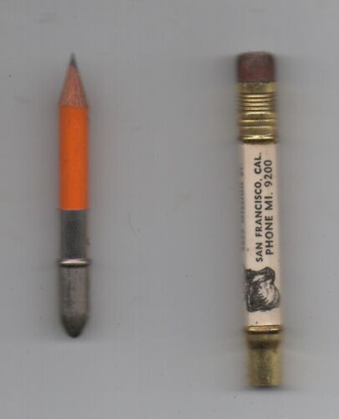

Notes: | ADD

Prop #
Prop Name:
Prop Type:
Script Location: | |
Character:
Quantity:
Research Images:

Notes:

